Technical brief
STEP 1: Product choice - Why Next.js?
Next.js is an open-source React framework maintained by Vercel that enhances the development experience for building web applications.
It is widely used.
Key Benefits
- Server-Side Rendering (SSR): Generates pages on the server for each request
- Static Site Generation (SSG): Pre-renders pages at build time
- API Routes: Built-in API routing system for serverless functions
- File-Based Routing: Simplified navigation through file structure
- Built-In CSS and Sass Support: Easy styling implementation
- Automatic Code Splitting: Loads only necessary JavaScript for current page

Common Use Cases
- Static Websites: Blogs, landing pages, and portfolio sites
- E-Commerce Sites: Fast-loading product pages optimized for SEO
- Corporate Websites: Scalable sites for handling significant traffic
- Web Applications: From simple dashboards to complex web apps
- Blogs and Content Sites: Easy-to-maintain, SEO-friendly content platforms

STEP 2: Preparation of the Next.js Application
- Created the GitHub Repository for this project (i.e. terraform-portfolio-project) and initialized the repository with a README file.
- Cloned the repository to my laptop:
git clone https://github.com/gkinthaert/terraform-portfolio-project.git
cd terraform-portfolio-project
- Cloned the Next.js Portfolio Starter Kit
npx create-next-app@latest gk-blog --use-npm --example https://github.com/vercel/next-learn/tree/main/basics/learn-starter
Note: gk-blog is the name that I gave my blog foler – this could be anything. The rest of the code is a standard next.js template to instantiate a next.js in this folder location
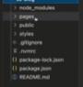
- Accessed the gk-blog subfolder in the project directory and started the development server:
cd gk-blog
npm run dev

- The Next.js application can now be accessed at http://localhost:3000/
STEP 3: Created the Configuration File
  - Created a new file called next.config.js, located in the root of the project folder
  - Pasted the following code into the file:
/**
* @type {import('next').NextConfig}
*/
const nextConfig = {
output: 'export',
}
module.exports = nextConfig
STEP 4: Built the Project
After setting up the configuration in step 3, ran the build command:
npm run build
This generates a static export of the Next.js application in the out directory, which can be deployed to any static hosting service.
This is basically a deployable build!
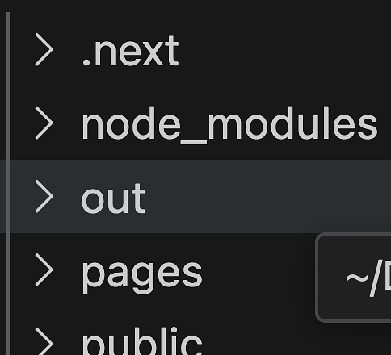

STEP 5: Initialized Git and Pushed to GitHub
git init
git add .
git commit -m "Initial commit of Next.js portfolio starter kit"
git remote add origin https://github.com/gkinthaert/terraform-portfolio-project.git
git push -u origin master

STEP 6: Created a Loom Video
Some additional info on the Next.js code structure, and key files and folders
- Added Video to README
- Pushed README Changes
git add README.md
git commit -m "Add Loom video link"
git push

STEP 7: Set Up Terraform Configuration
- Created Project Directory for the Terraform files
mkdir terraform-nextjs
cd terraform-nextjs
- Created Terraform Files
a. State File with S3 + DynamoDB
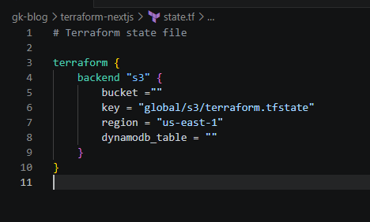
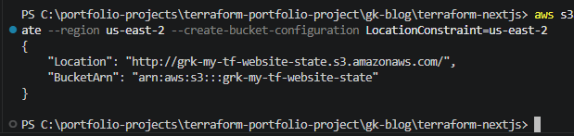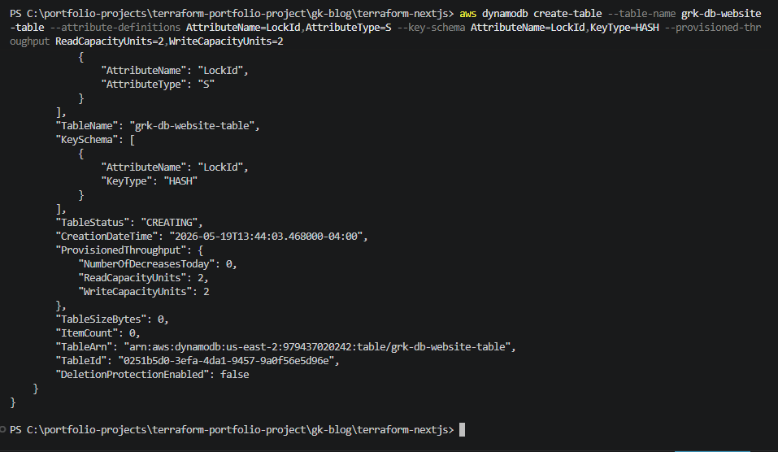
** note: should be LockID instead of LockId – had some mismatch on this attribute
b. Main.tf
added the Terraform provider block
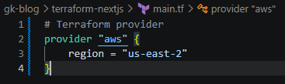
Added the resources
S3 resource
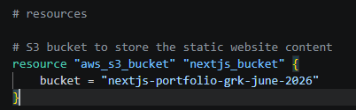
Set up ownership of the S3 bucket
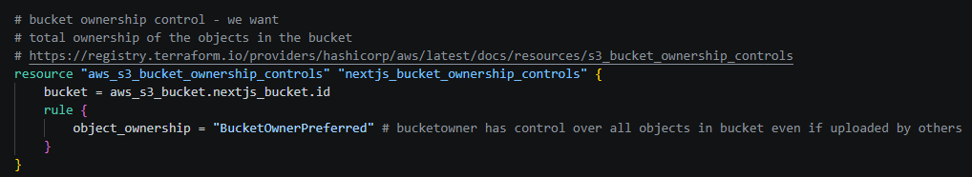
Remove public access blocking
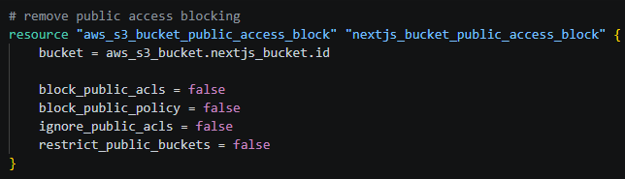
Set up a bucket ACL to allow public read access
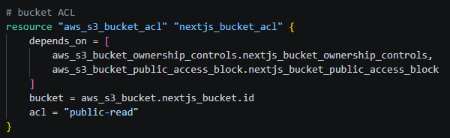
Set up a bucket policy to allow the public read access
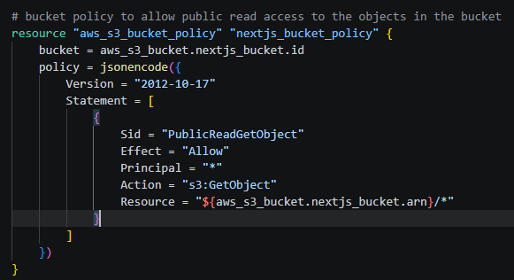

e. CloudFront Distribution
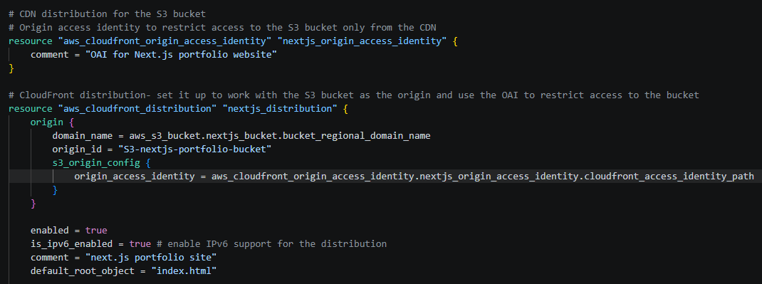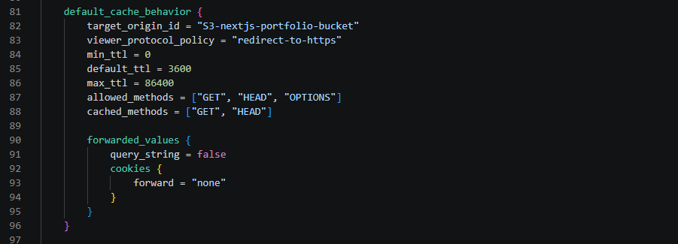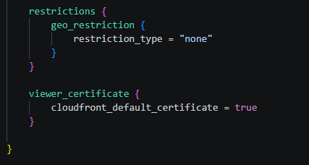

STEP 8: Initialized and Applied Terraform
- terraform init
- terraform plan
- # Review for any issues and resolve if needed
- terraform apply
- terraform show: d386u1c08xqc1i.cloudfront.net ** this will be different on next terraform apply
STEP 9: Uploaded the Next.js Static Site to S3
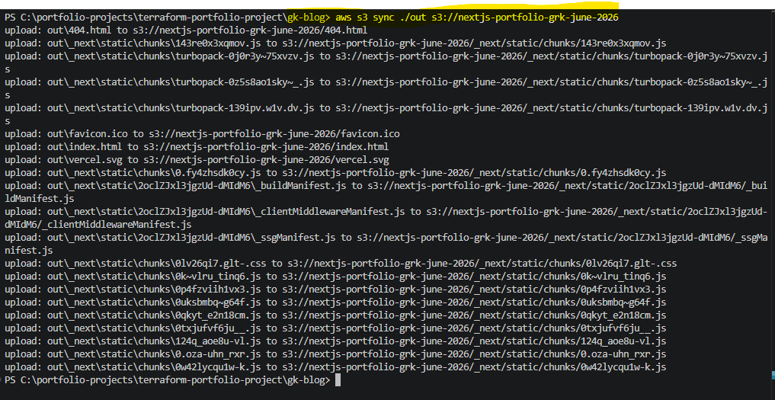Note: check that it is the correct path to the Next.js build output folder and the correct S3 bucket name. The Next.js output folder is ./out, and Bucket name is nextjs-portfolio-grk-june-2026
STEP 10: Access the Deployed Website
- Get the CloudFront URL (from STEP 8 Terraform show)
- Access Your Website Open the CloudFront URL in a web browser to view the deployed Next.js portfolio site.

Reference: official Terraform AWS documentation

